**Software Design Document - Appendix B – Sequence Diagrams**

1. **Register (SCMS-UC-01)**

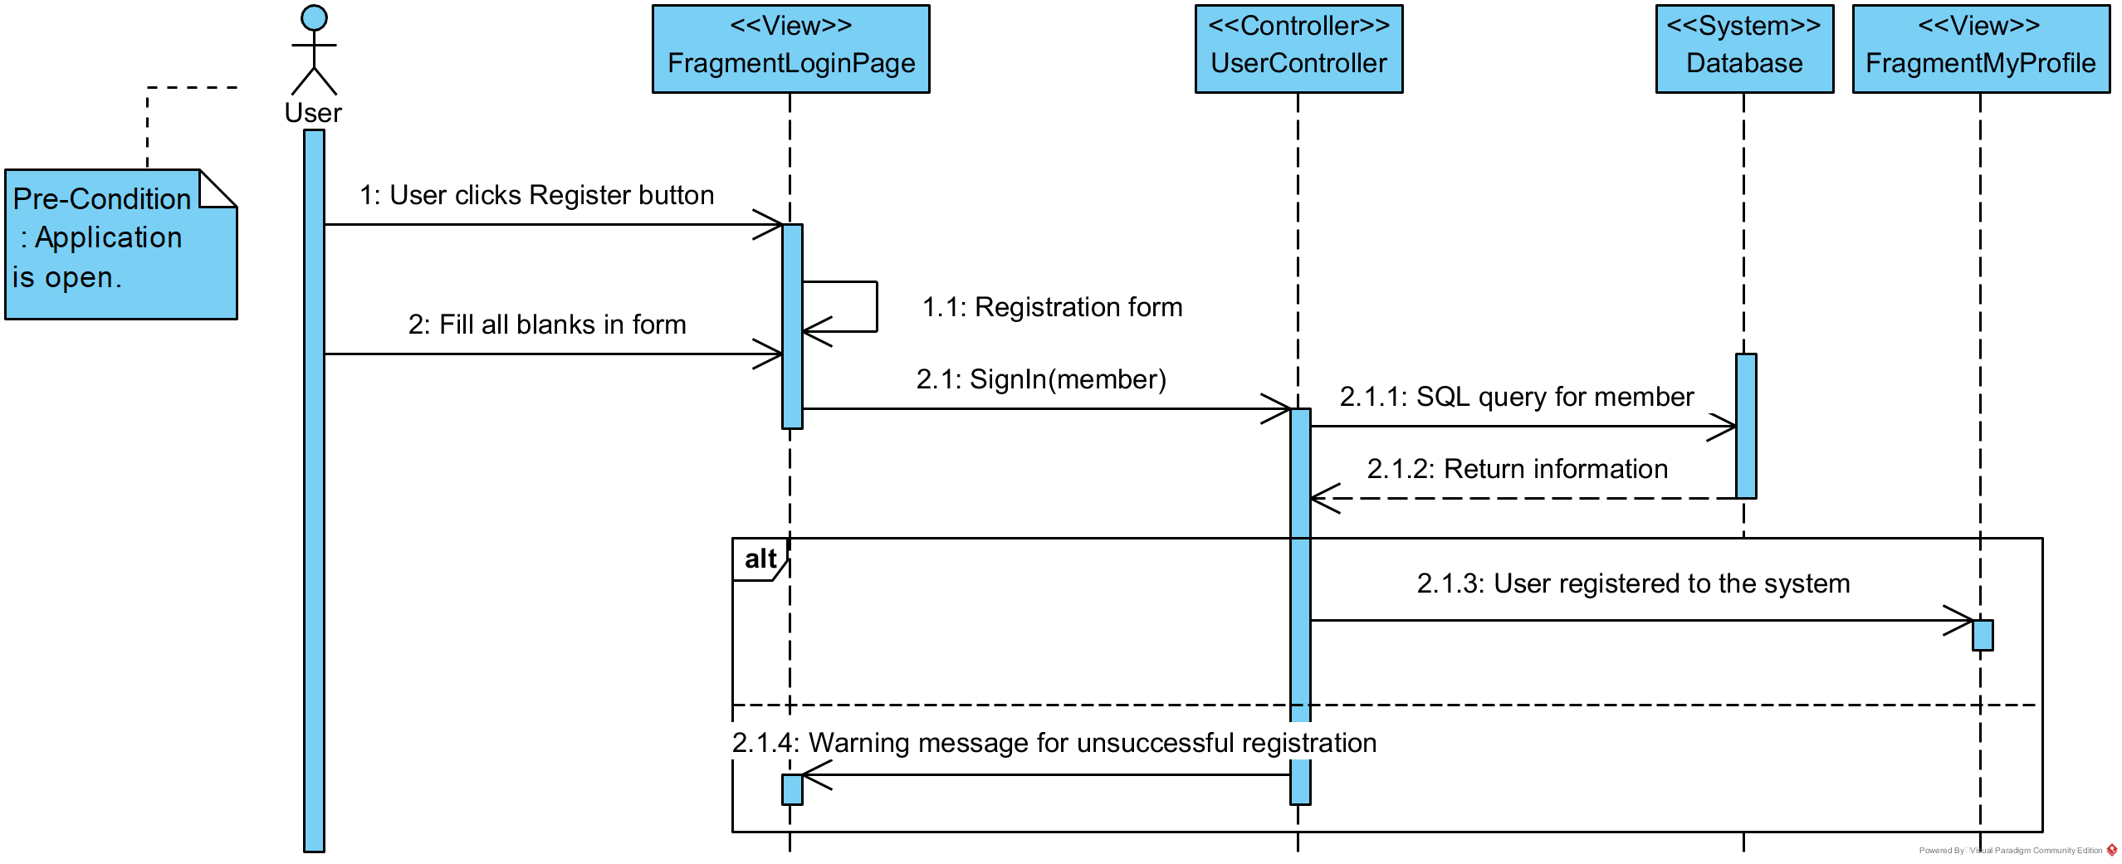

1. **Login (SCMS-UC-02)**

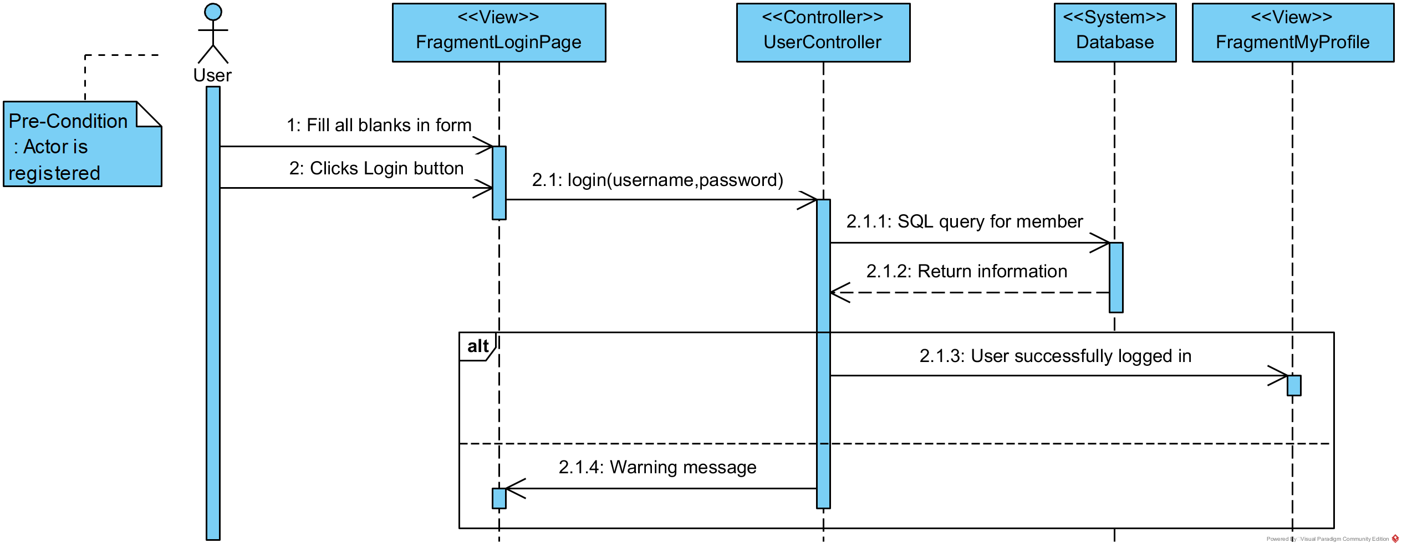

1. **Logout (SCMS-UC-03)**

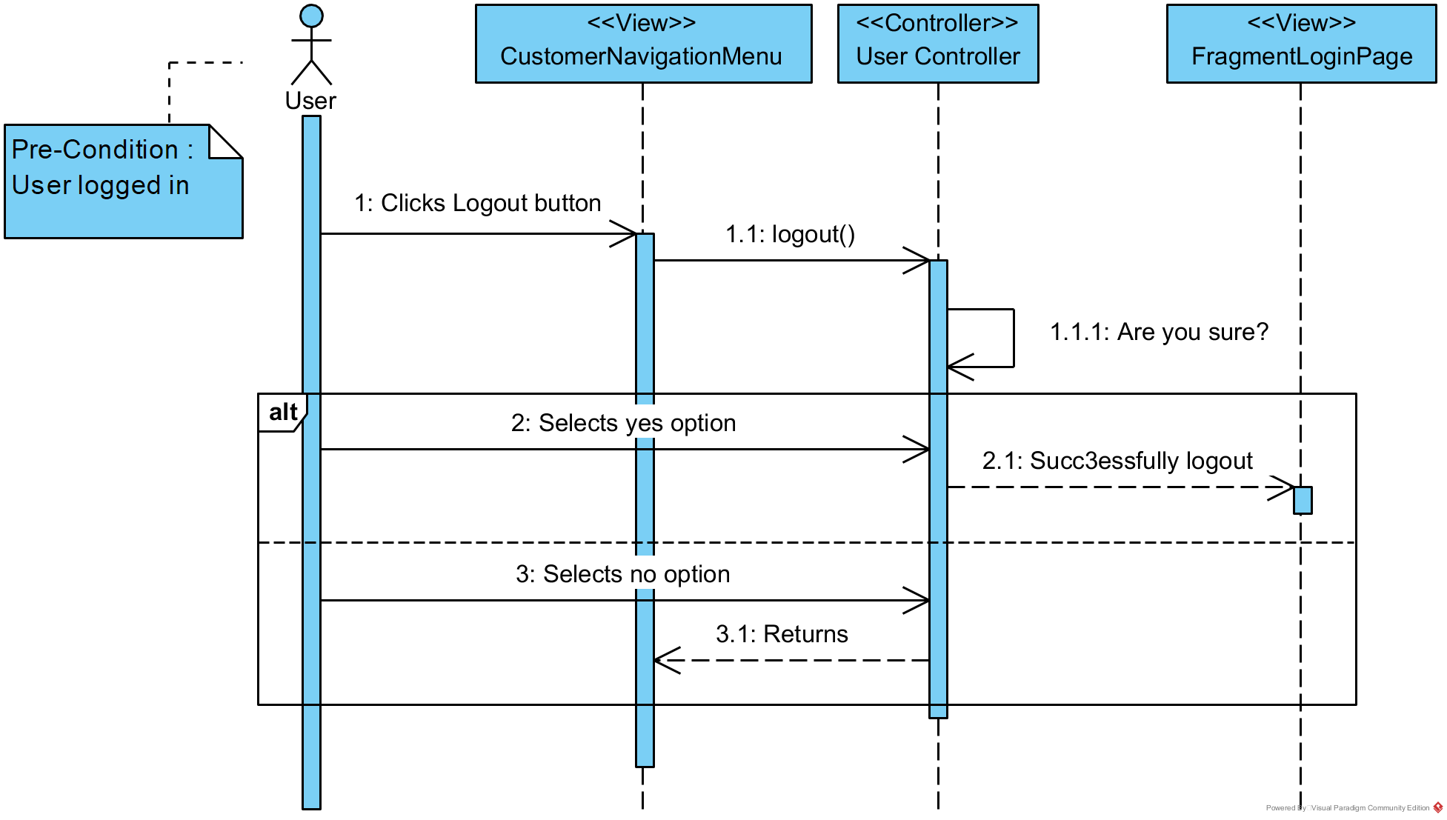

1. **Pay membership fee (SCMS-UC-04)**
2. **Show user profile (SCMS-UC-05)**
3. **Show joined courses (SCMS-UC-05-2)**
4. **Show user schedule (SCMS-UC-05-3)**
5. **View branch fullness (SCMS-UC-06)**

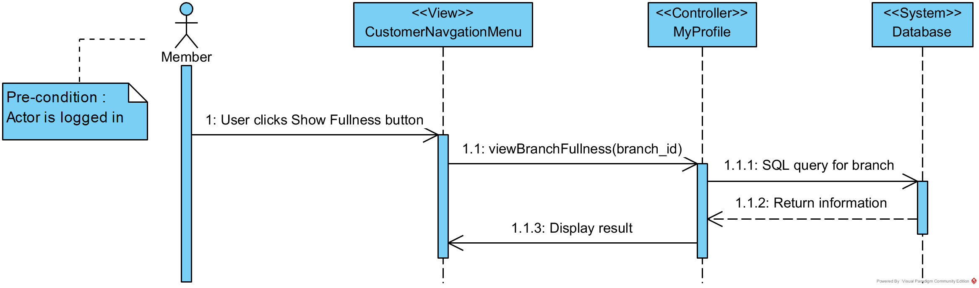

1. **Show special offer (SCMS-UC-07)**

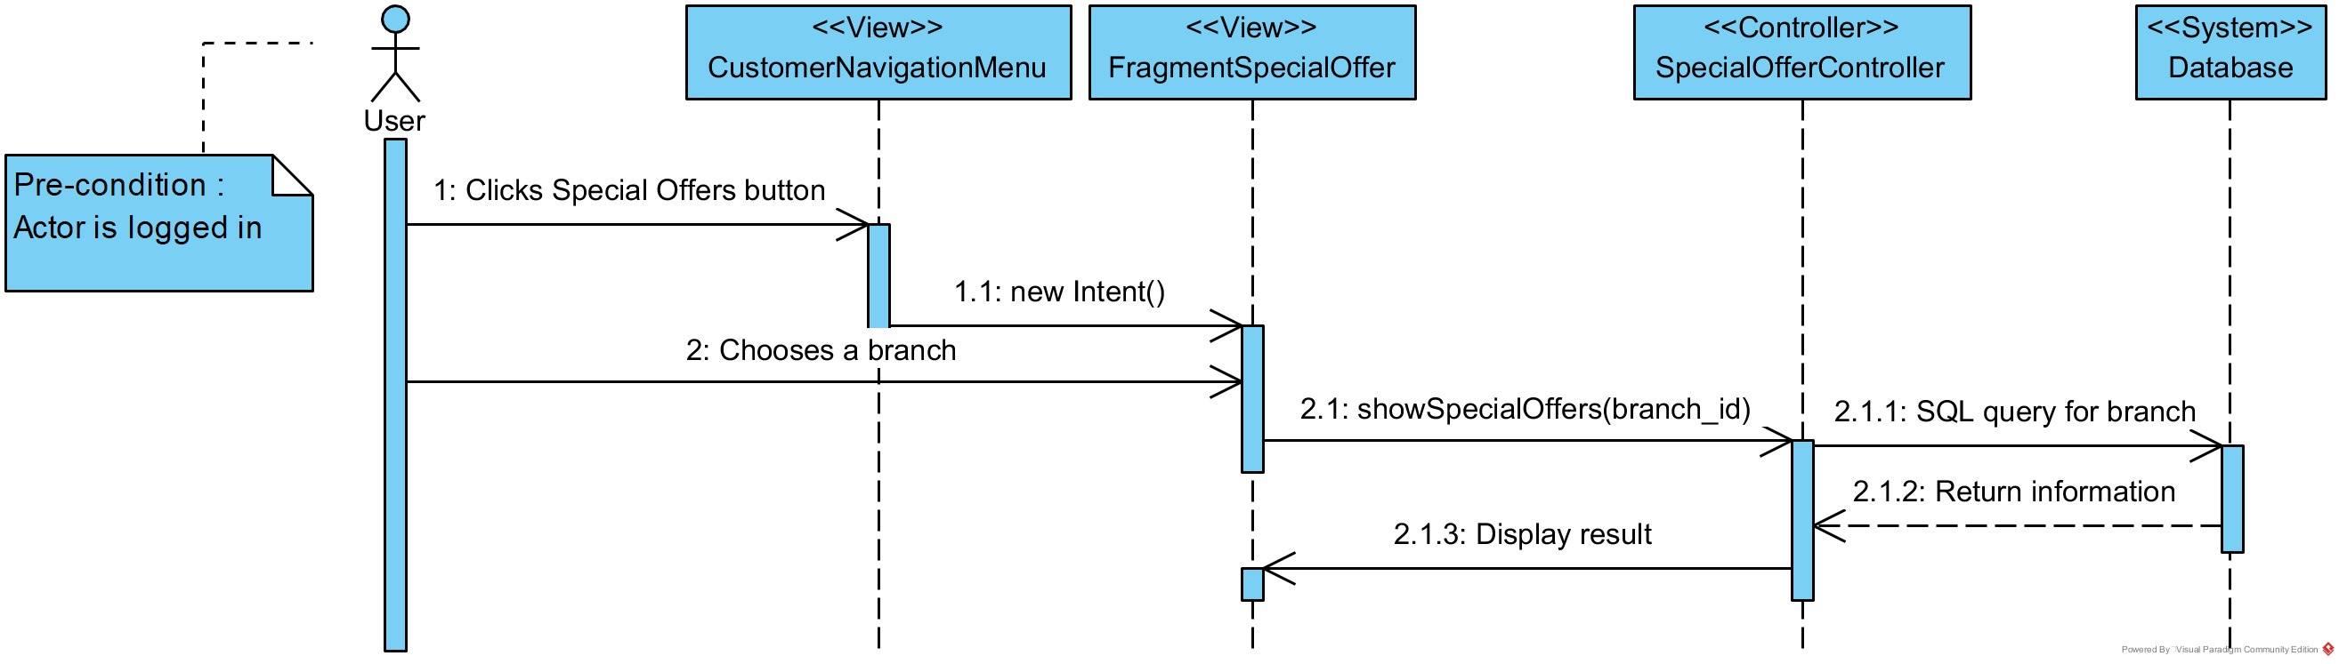

1. **Apply special offer (SCMS-UC-08)**
2. **Show general information about sports center (SCMS-UC-09)**
3. **Upgrade membership statue (SCMS-UC-10)**
4. **Show all courses (SCMS-UC-11)**
5. **Show course information (SCMS-UC-12)**
6. **Enroll/Payment for course (SCMS-UC-13)**
7. **Add new course (SCMS-UC-14)**
8. **Delete course (SCMS-UC-15)**
9. **Create special offer (SCMS-UC-16)**

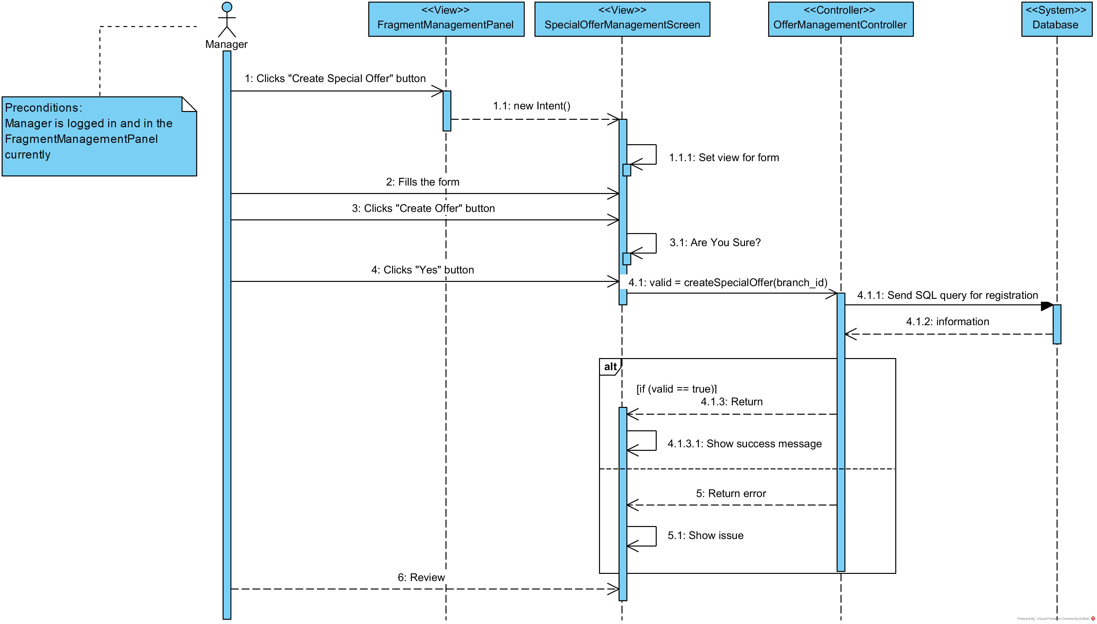

1. **Ban user (SCMS-UC-17)**

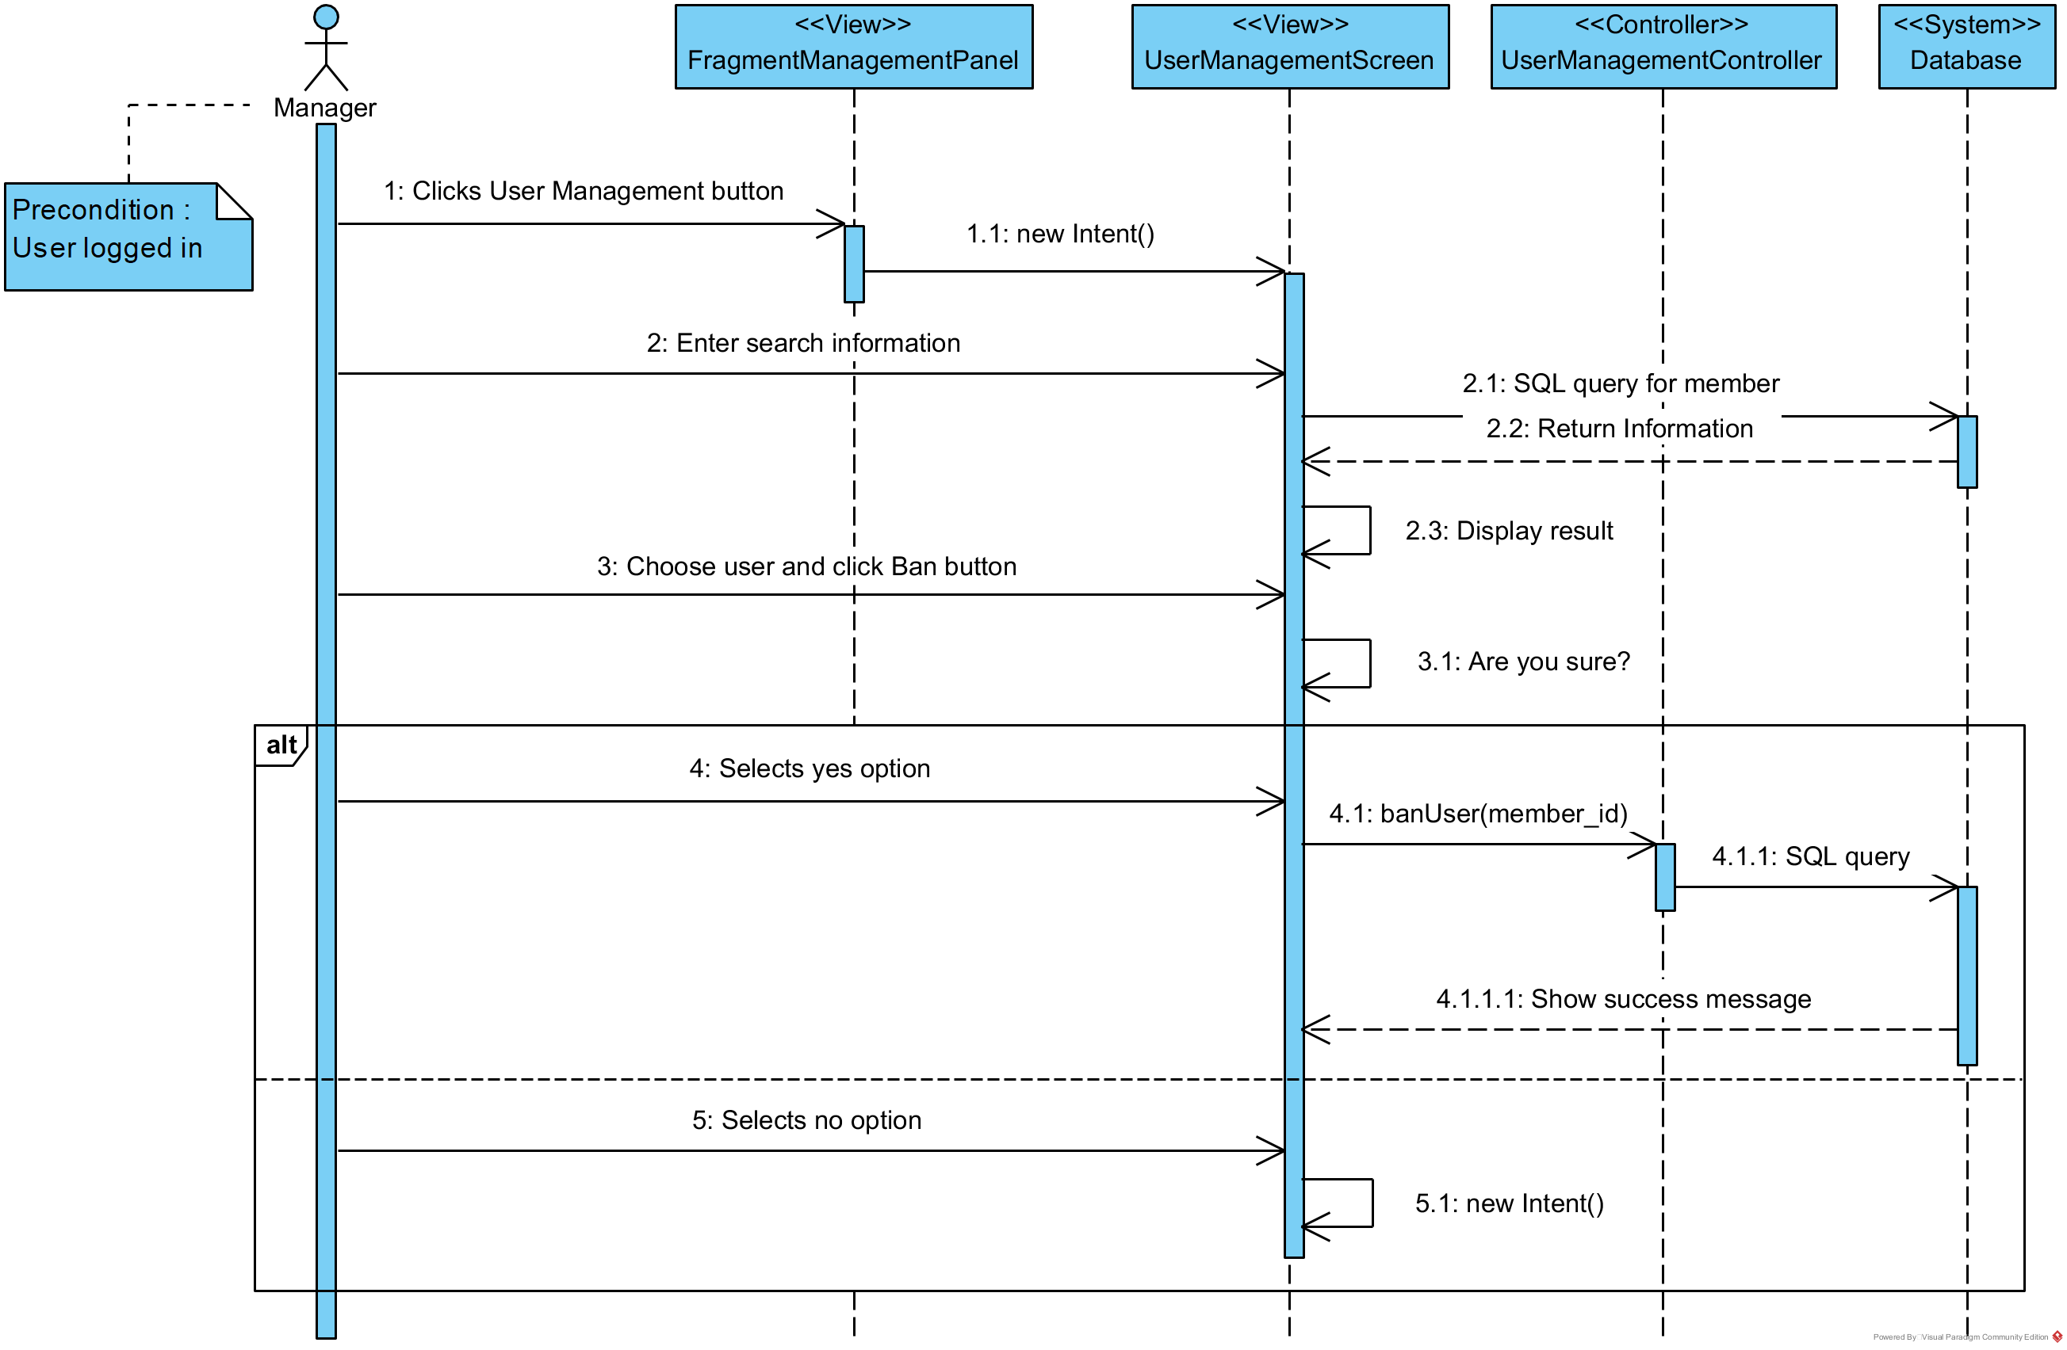

1. **Add user (SCMS-UC-18)**

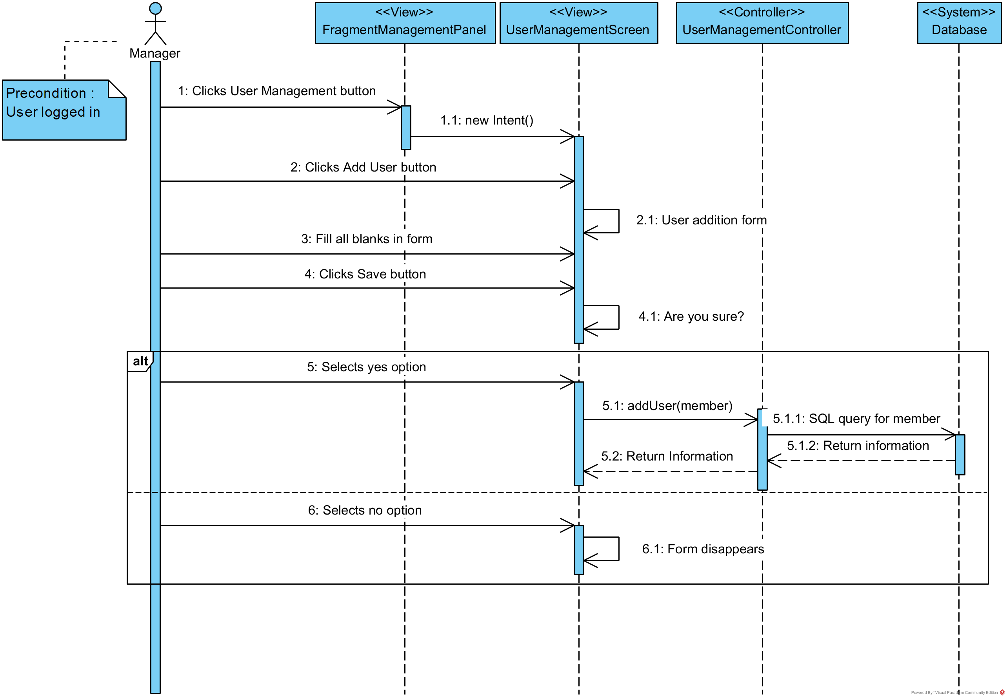

1. **Update user (SCMS-UC-19)**

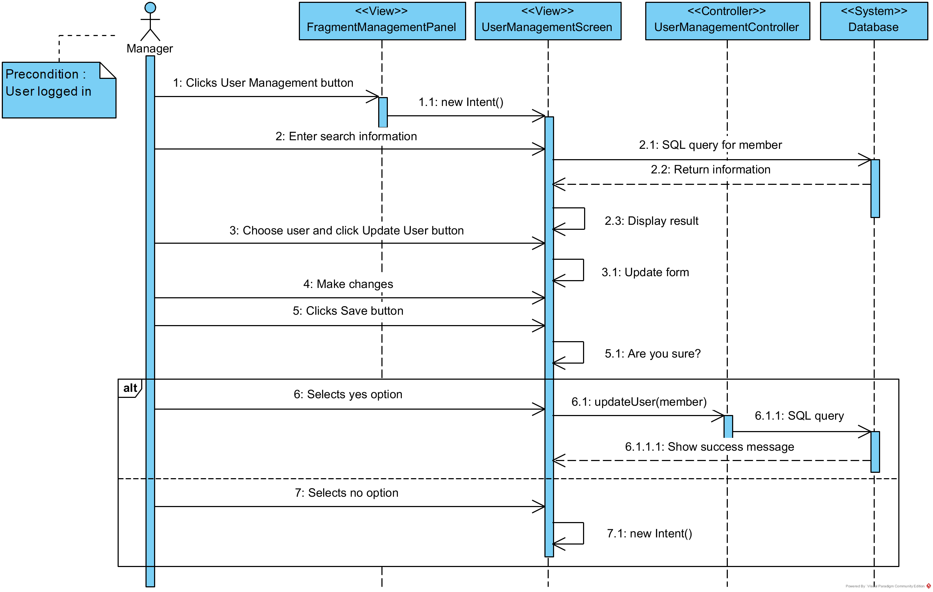

1. **View branch stats (SCMS-UC-20)**

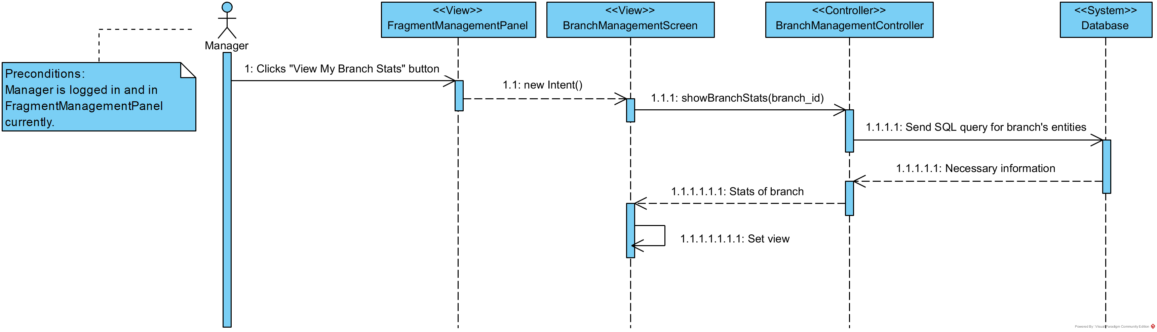

1. **Add new branch (SCMS-UC-21)**

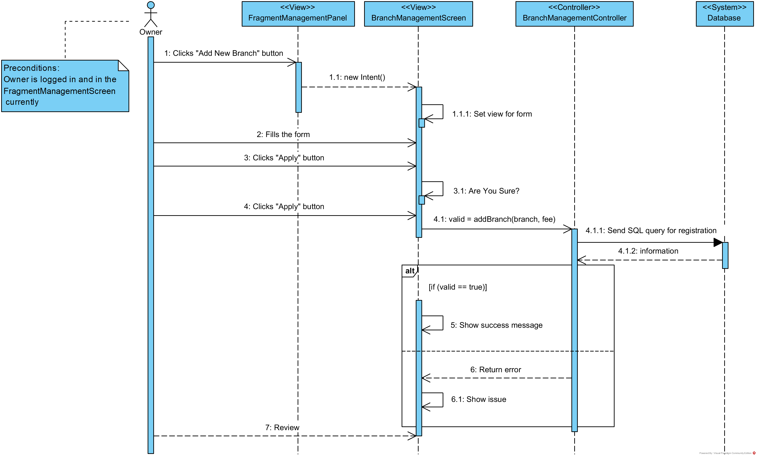

1. **View all branch stats (SCMS-UC-22)**

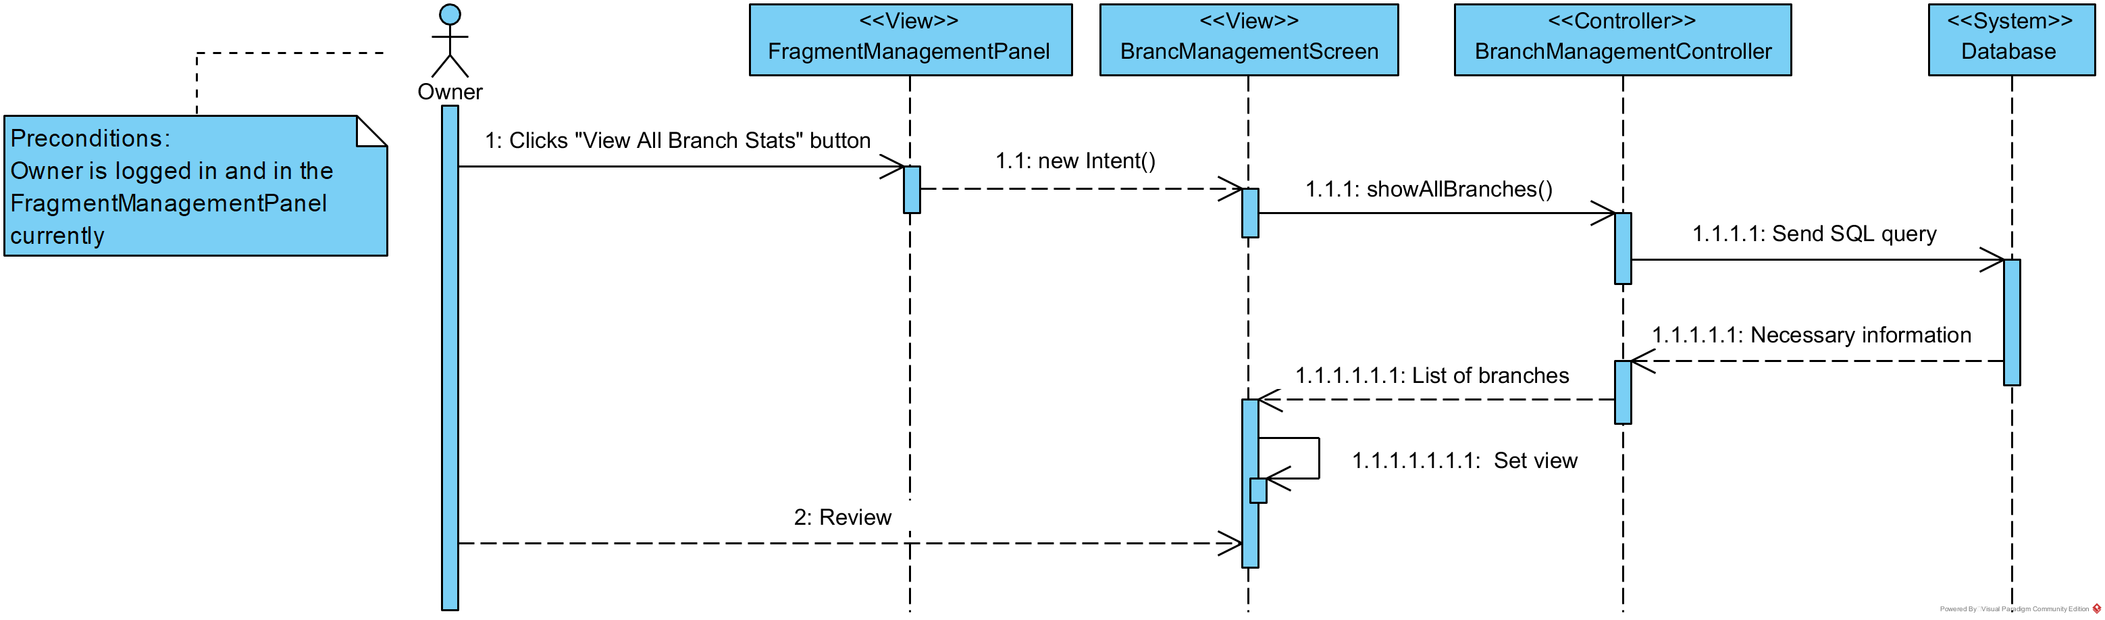

1. **Delete manager (SCMS-UC-23)**

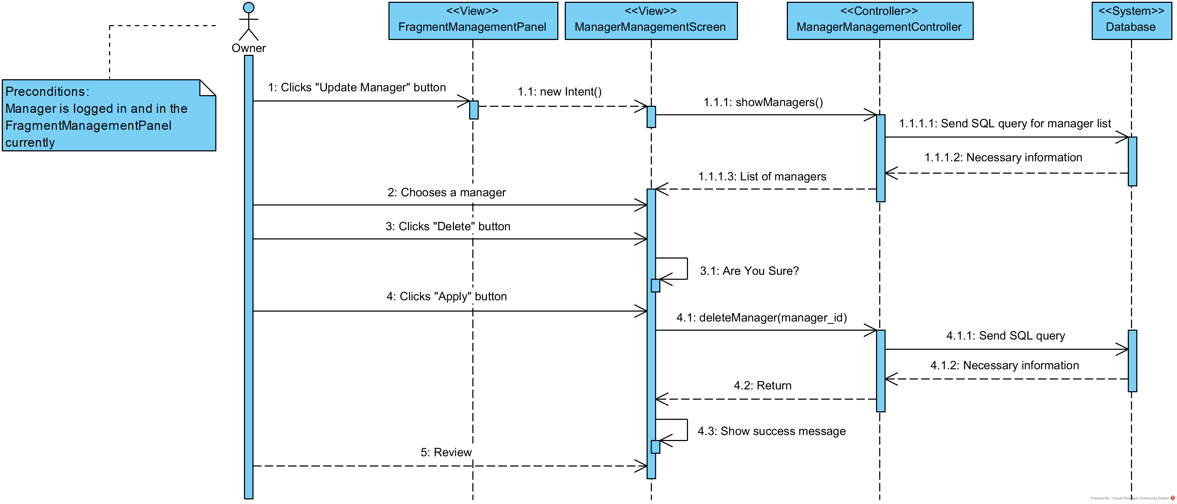

1. **Add manager (SCMS-UC-24)**

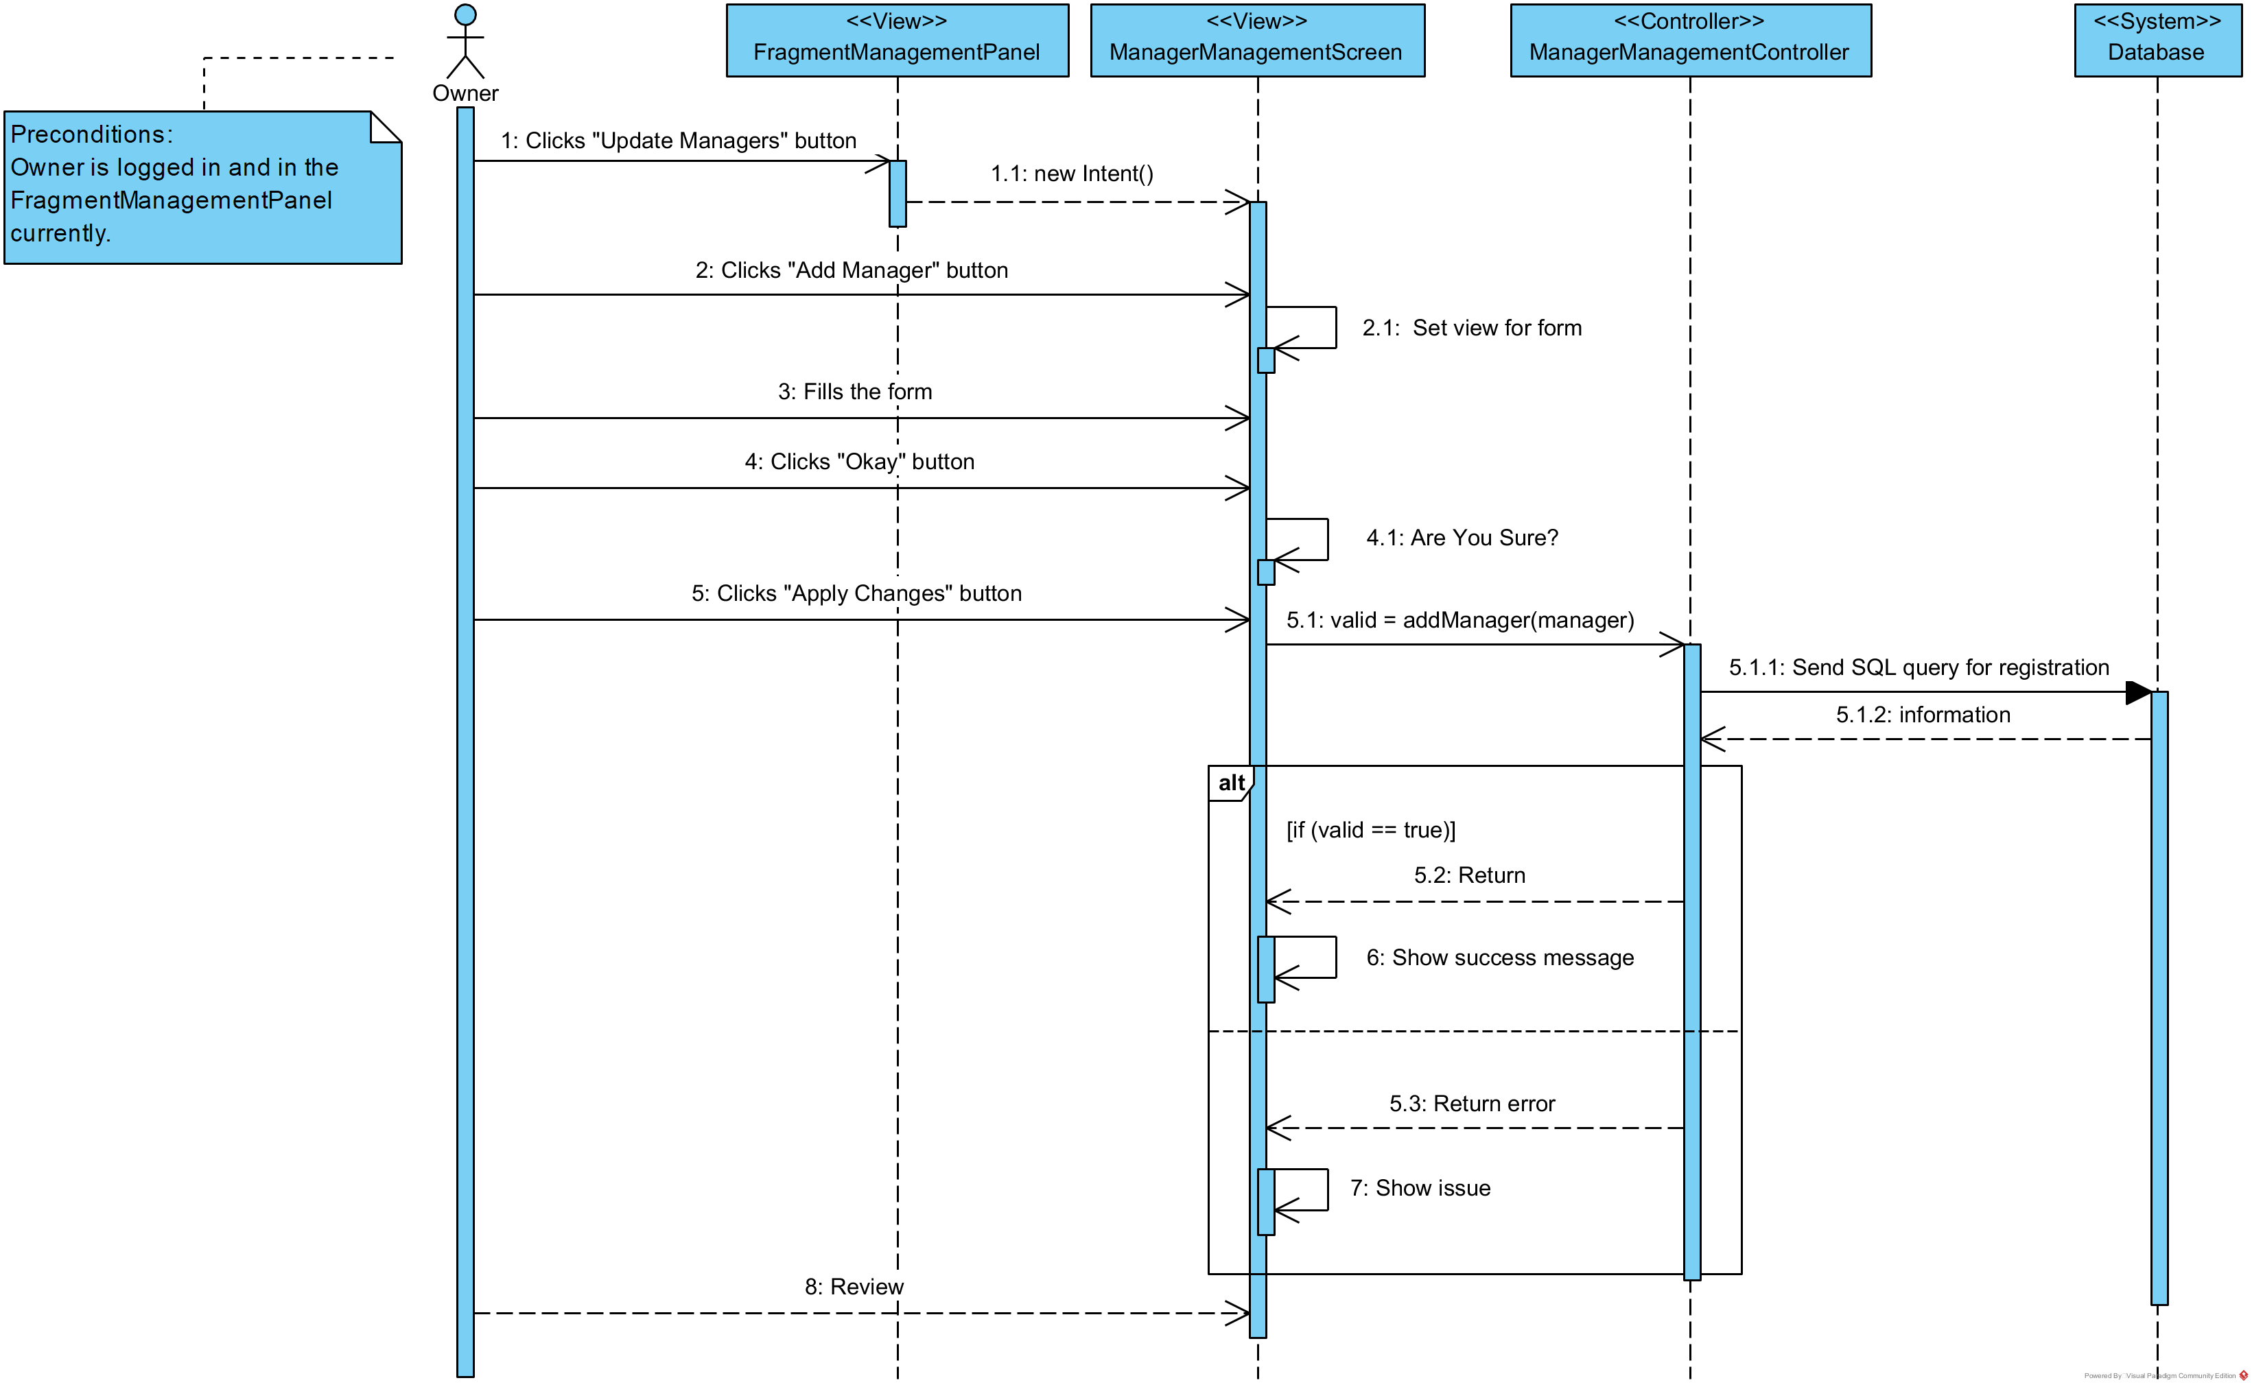

1. **Update manager (SCMS-UC-25)**

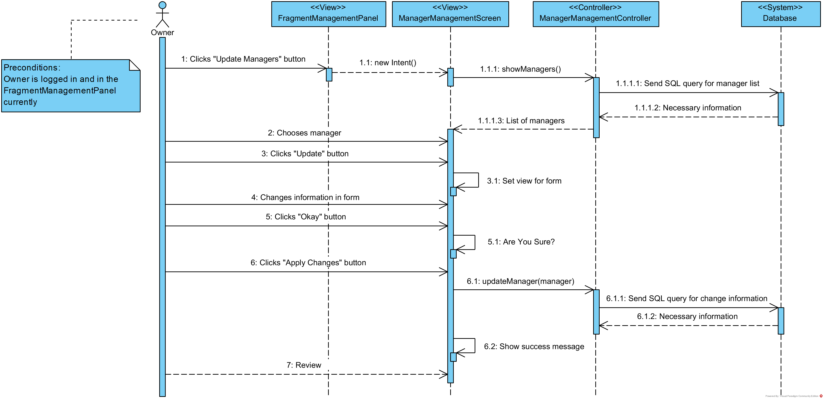

1. **Drop course (SCMS-UC-26)**
2. **Update profile (SCMS-UC-27)**

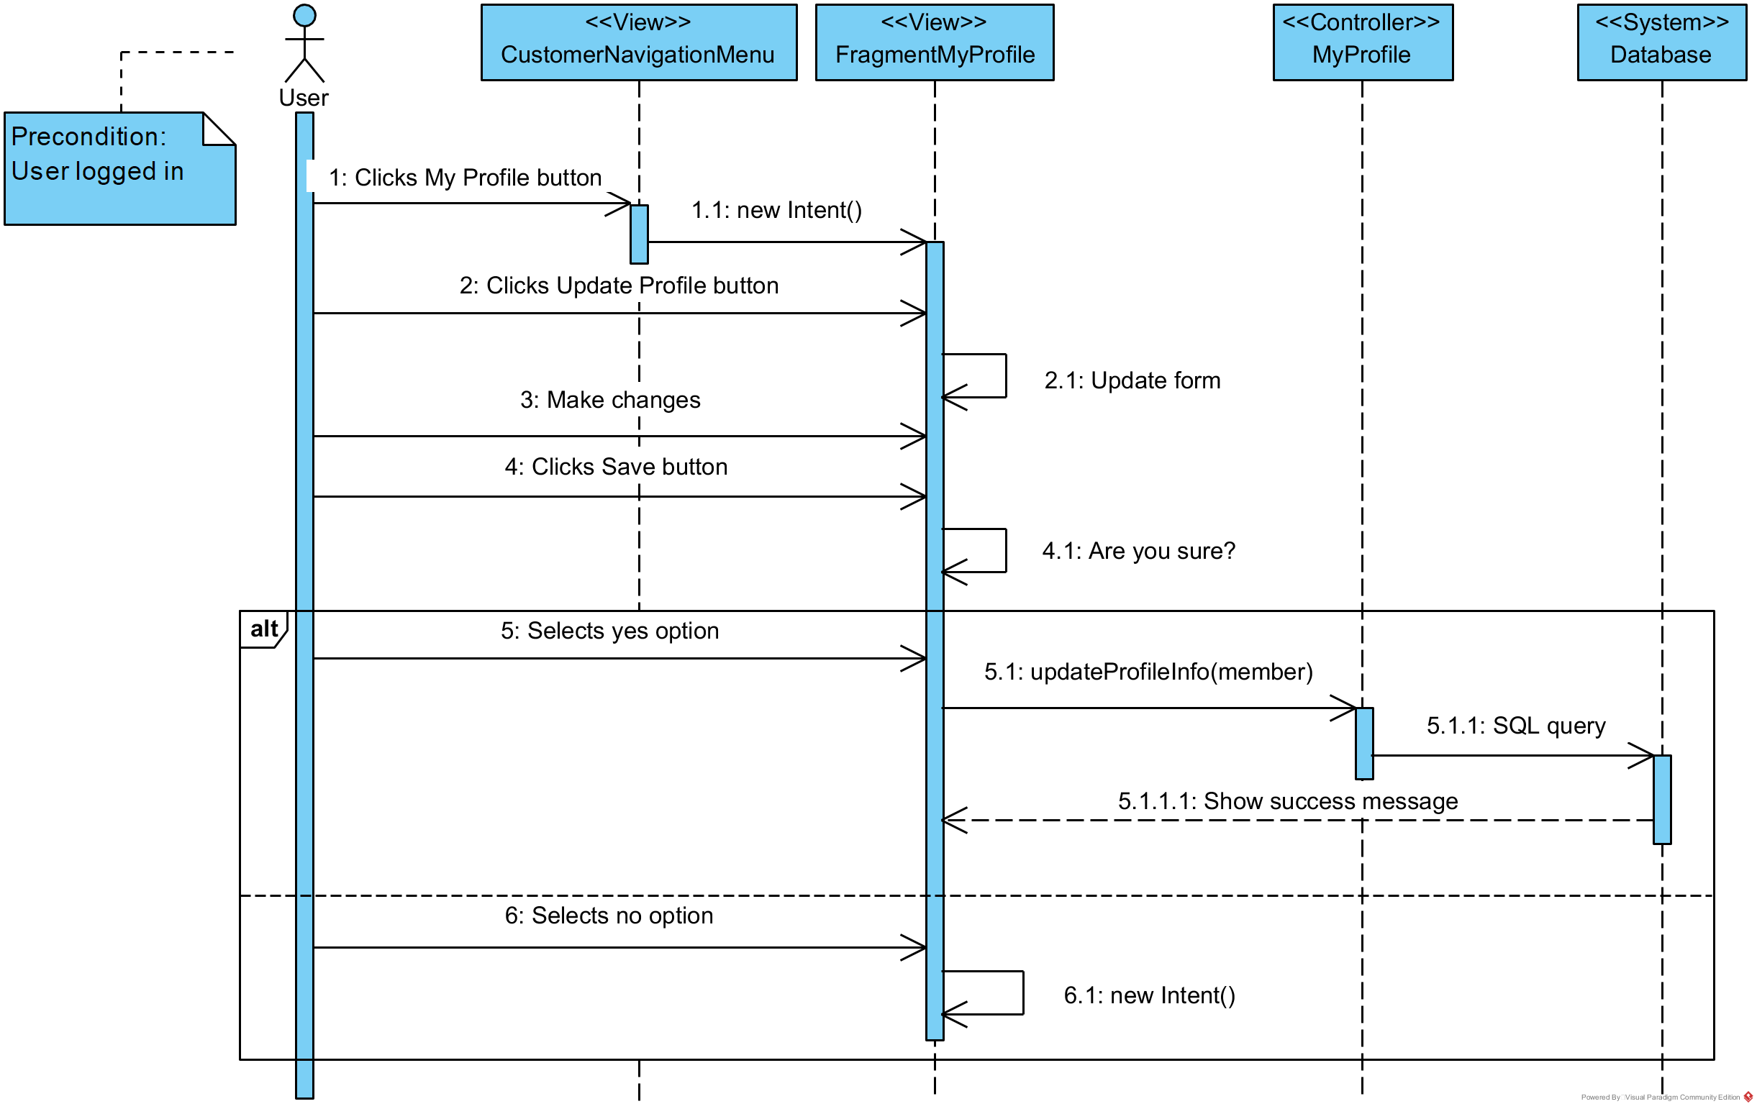

1. **Show trainees (SCMS-UC-28)**

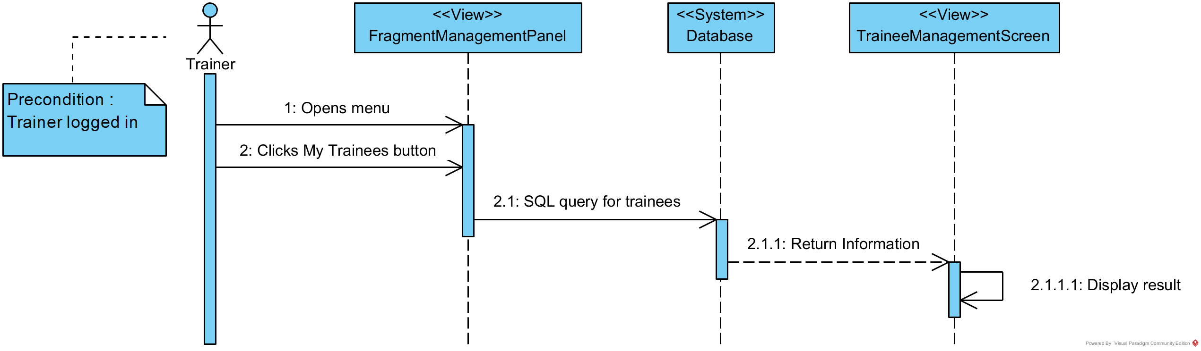

1. **Update activity plan(SCMS-UC-29)**

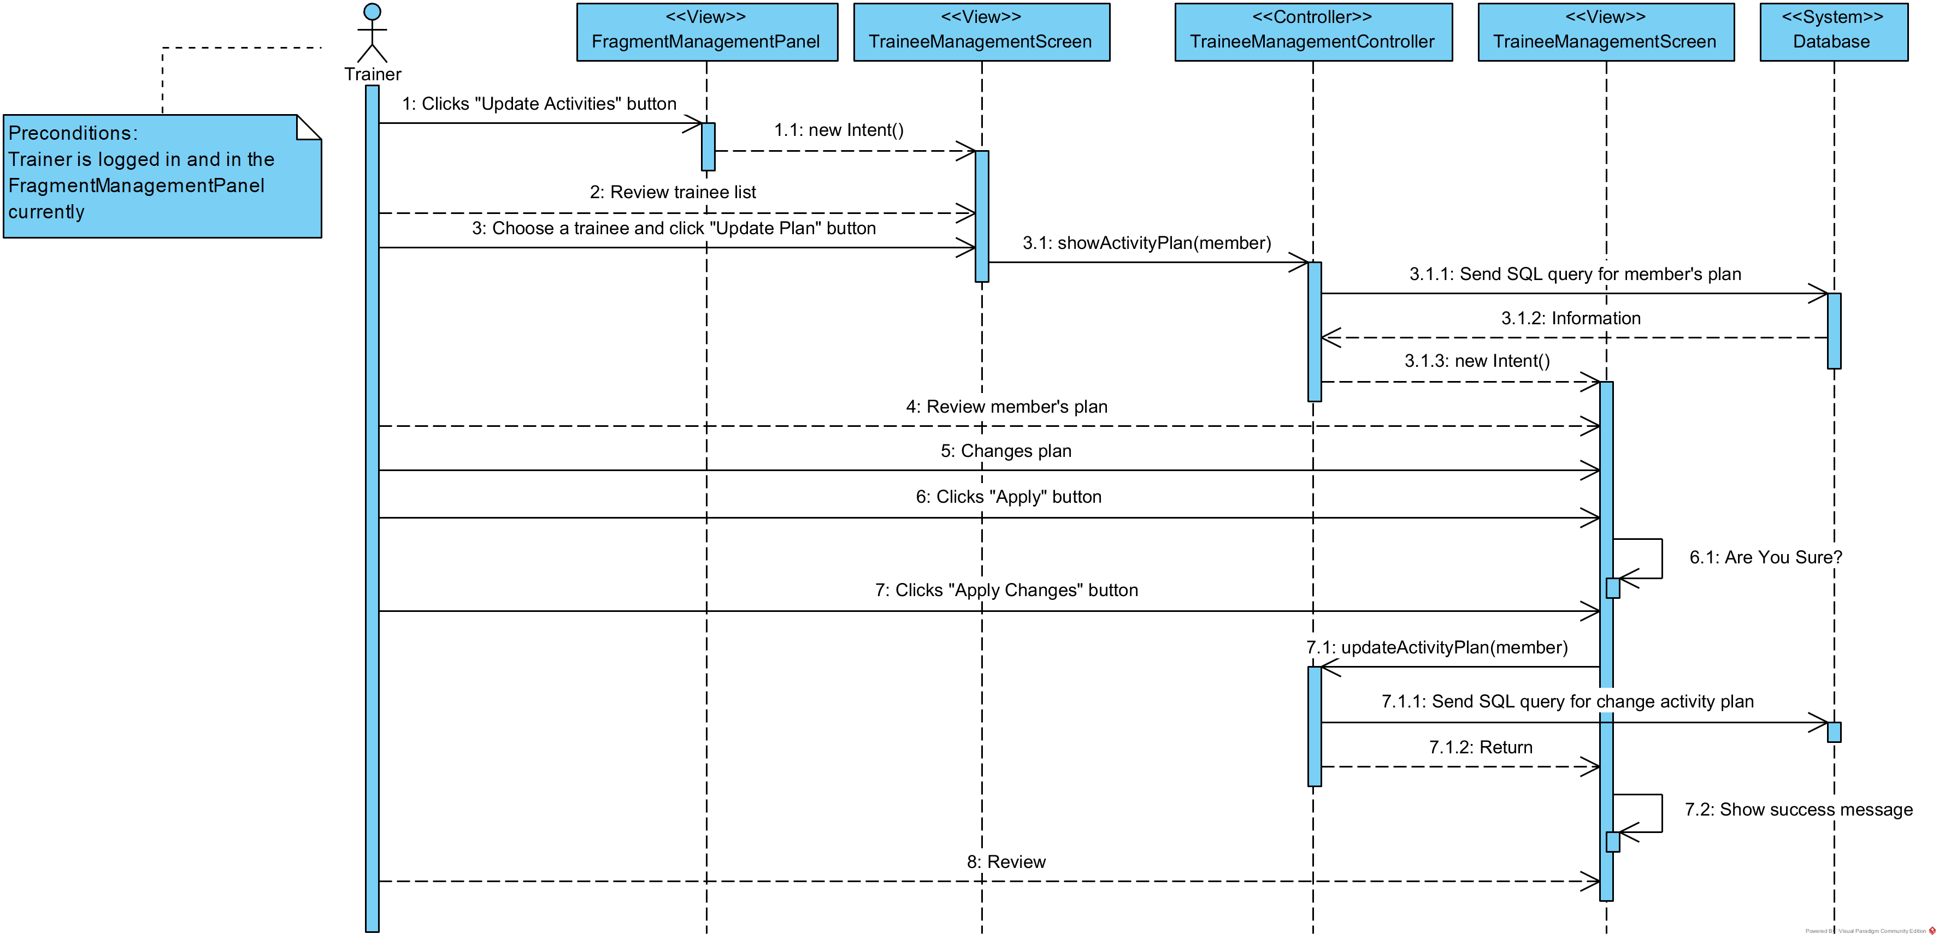

1. **Add trainer (SCMS-UC-30)**

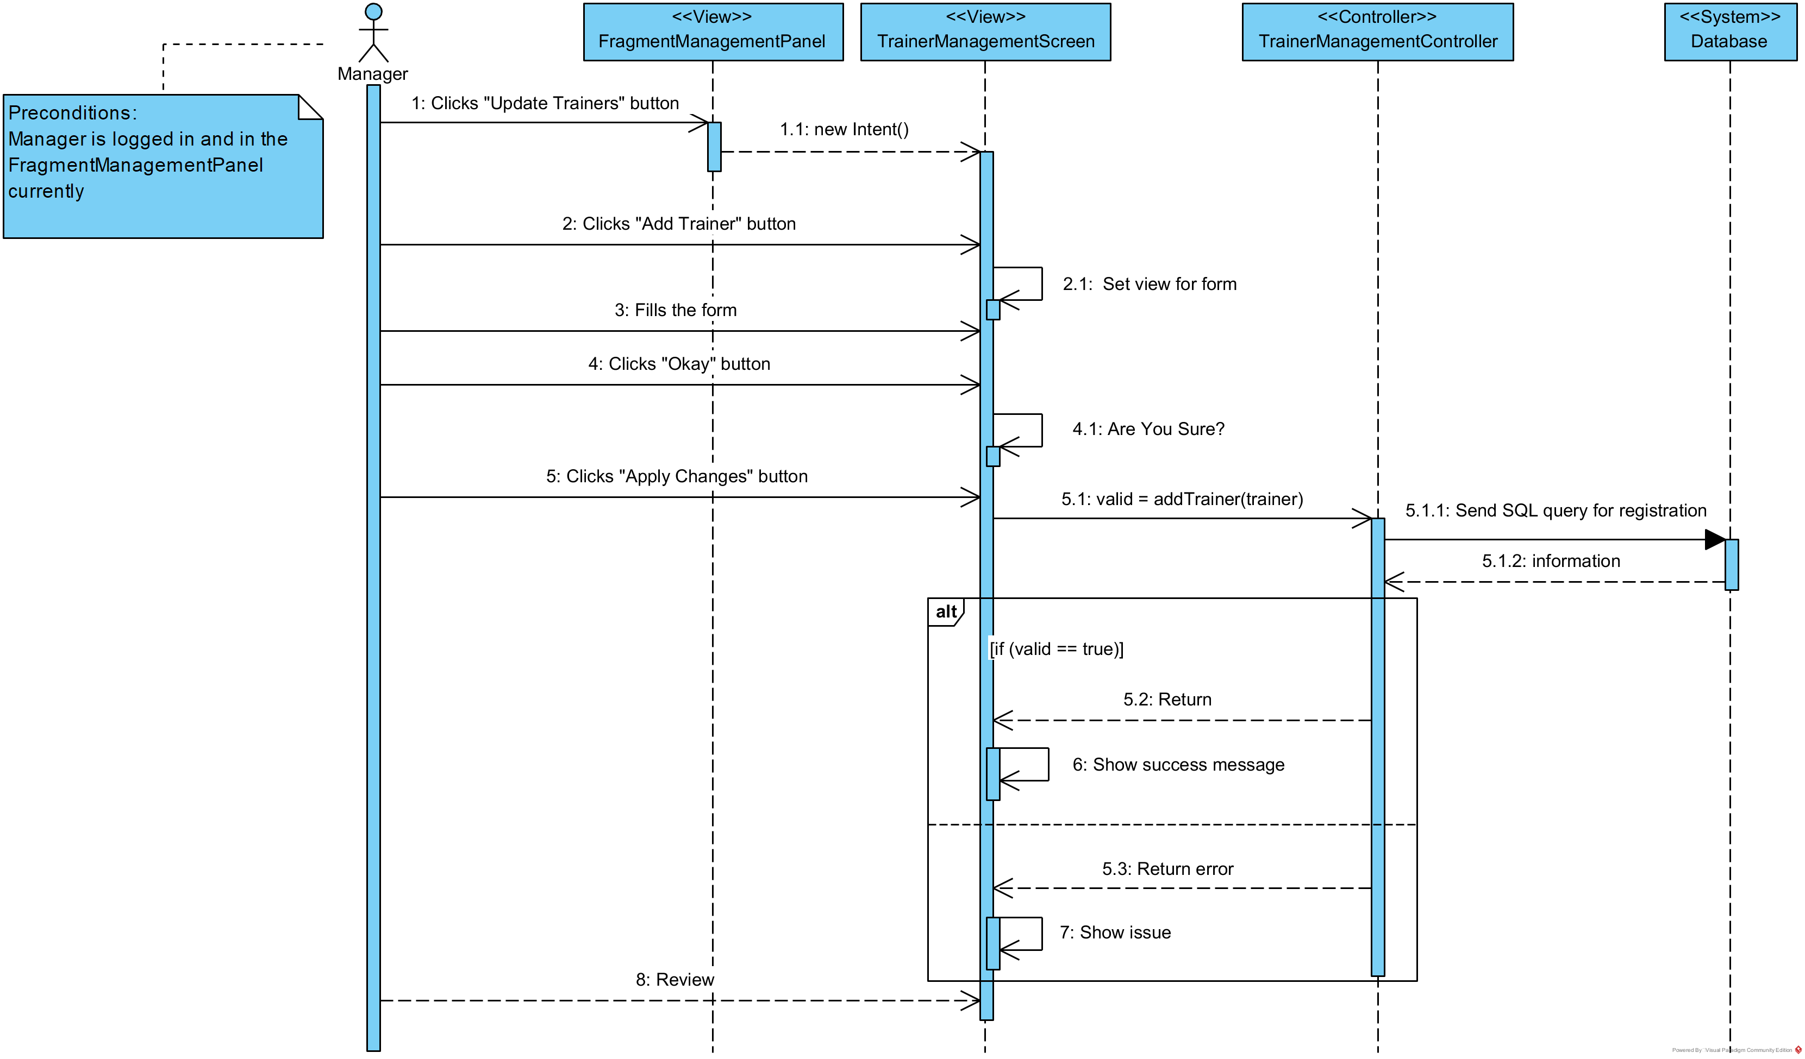

1. **Update trainer (SCMS-UC-31)**

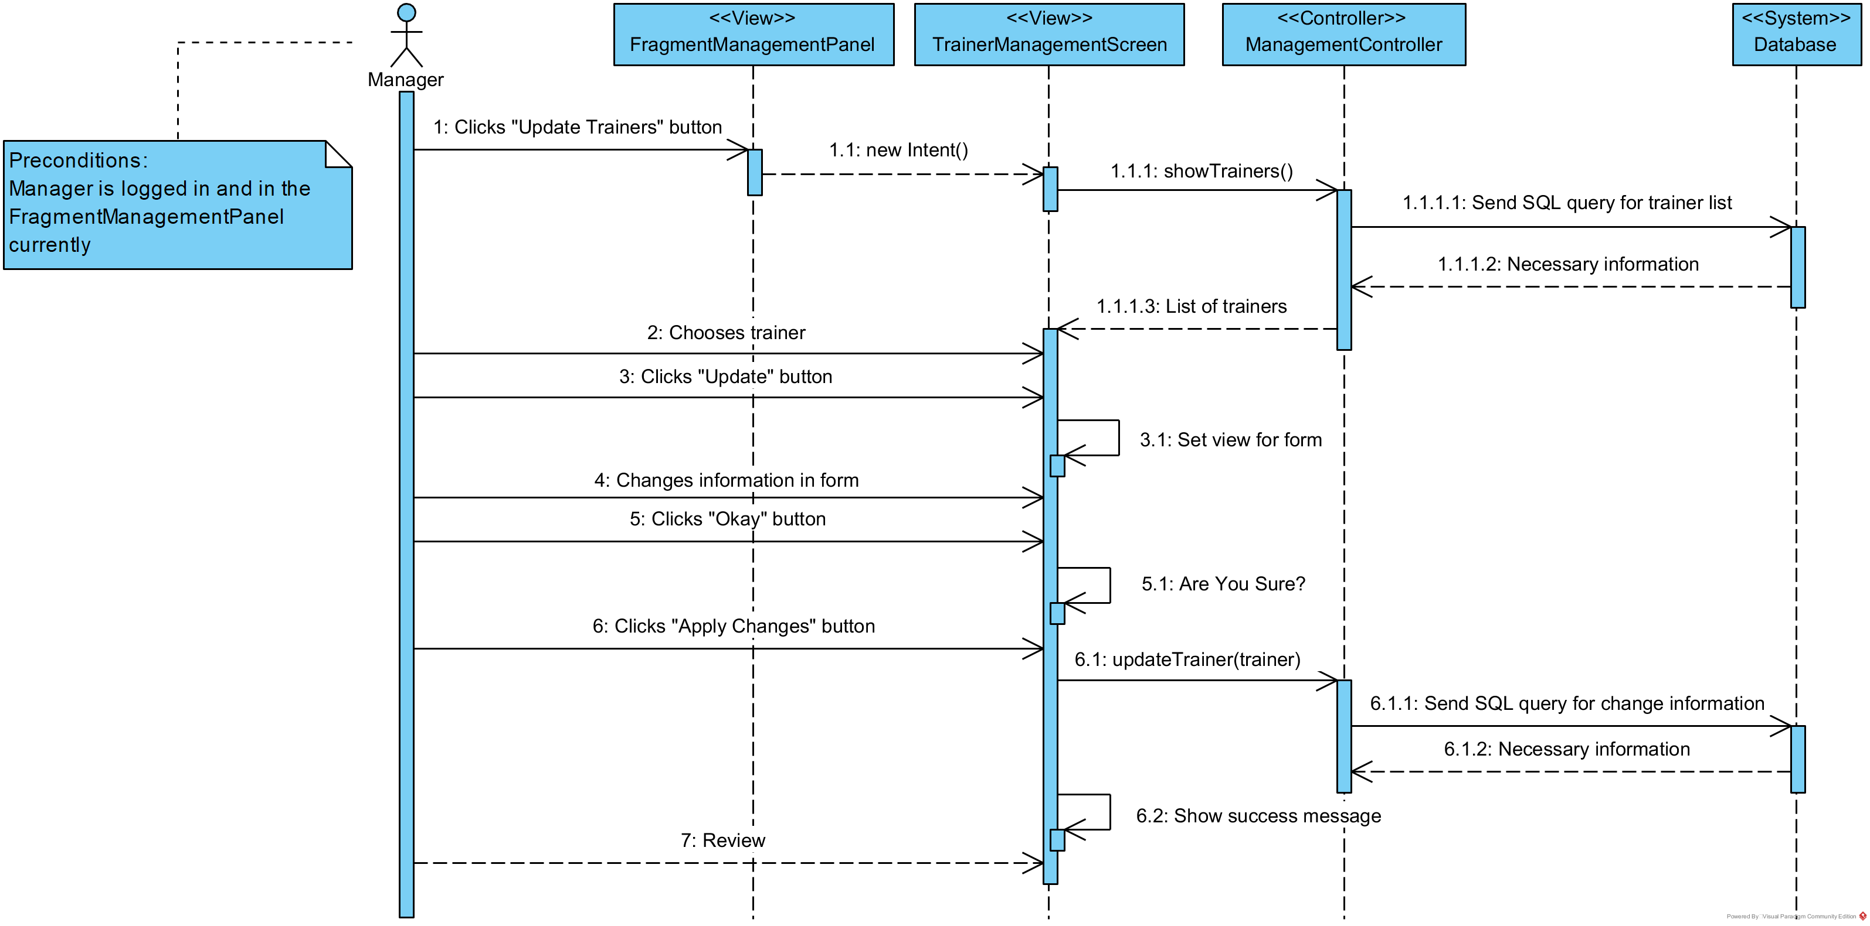

1. **Delete trainer (SCMS-UC-32)**

